Team 1 Open Source Air Quality Monitoring

Week 17: May 1st 2022 - May 8th

Sponsor: Dr. [David Burnett](mailto:dburnett@pdx.edu)

Advisor: Dr. John Acken

Team Members: [Adam Dezay](mailto:adezay@pdx.edu), [Manuel Garcia](mailto:manga2@pdx.edu), [Brandon Hippe](mailto:bhippe@pdx.edu), Mercedes Newton

**Team Review:**

* Met with Dr. Acken in person to update team progress and outline a plan for the upcoming month.
* Finished PCB schematic, now focusing on PCB routing
* Pushed enclosure build date forward to give time for anemometer calibration
* Began enclosure design to be completed this week

**Individual Review**

Adam Dezay:

Updated wiki and began on making the manual for the machine including instructions for build. Focusing on learning how to design and build PCBs and learning how to use 3D printers in the EPL so I can be better help for Manuel and Mercedes

Manuel Garcia:

Turned over smartmesh progress to Brandon, and switched focus to PCB design and layout. After troubleshooting for a few months we are almost certain that we have the correct hardware configuration for the smartmesh, but still do not have code functioning for communicating the smartmesh with the host node. Going to continue making smartmesh progress while our PCB is printing.

Designed the first round PCB schematic, as a team we decided to make a hat for the msp430. Made key decisions on some components to use such as the battery management circuits, as well as what mosfets to use in order for proper voltage level shifting and putting sensors to sleep. Working on making the correct layout for the msp430 hat, so that it will fit right on top of the pins of our microcontroller. Should be able to send a board out for production within the next couple of days. Planning on using OSH park for the first round prints.

Brandon Hippe:

Switched to working on smartmesh integration with breadboard prototype. Running into a problem where smartmesh boards indicator LEDs don’t light up when power is supplied, except when physically pressing on the header pins with my fingers. Manny hasn’t had this issue, so I'm waiting to get my hands on one of the boards he’s been working with. Indicator LEDs not lighting up likely isn’t an issue for the project as long as the smartmesh boards are actually working, but troubleshooting the connection with the host node isn’t easy without them.

Mercedes Newton:

Focused on designing physical CAD models in FreeCAD. Began a 3d printing draft to be completed and put in the printing queue for the EPL by May 6th (designing to be printed by “Hyde” machine in EPL).

**Gantt Chart and Timeline Updates:**

Below is both the timeline of the projected project progress for spring term. Figure 1 represents the gantt chart for the term with expected completion dates beginning March 25th. All specific dates for the upcoming term are specified in the table below.

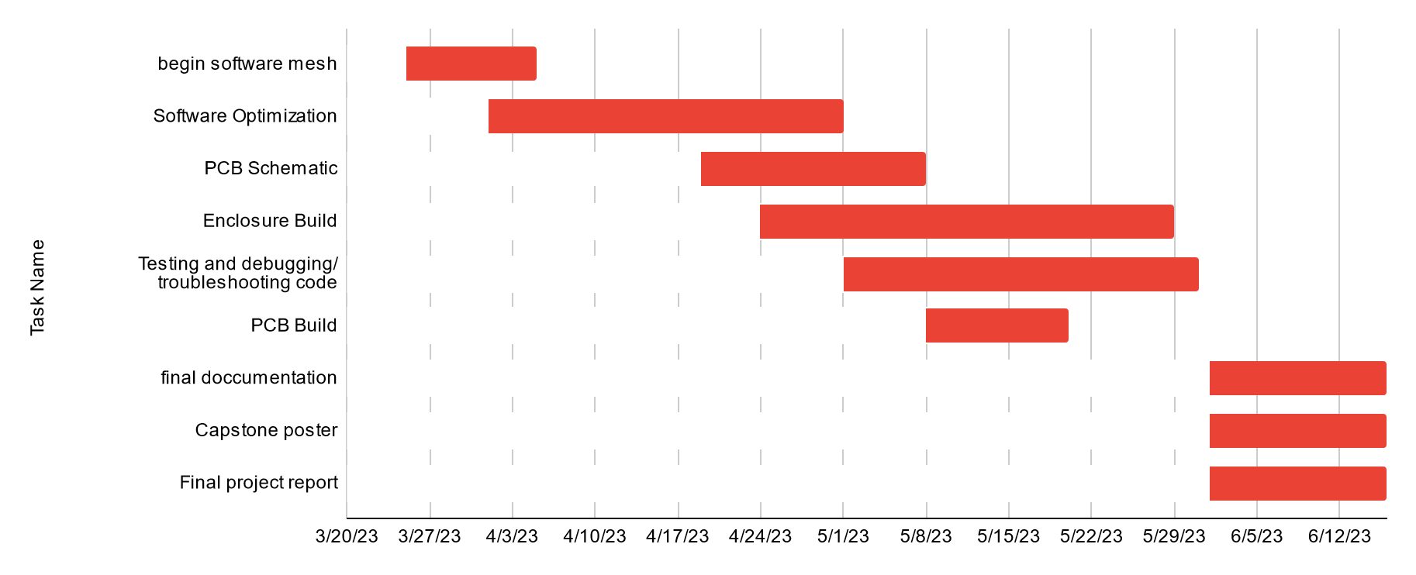

Figure One: Gantt chart for spring term (first task starts 3/25/2013)

| Task Name | Start date | End date |
| --- | --- | --- |
| Begin software mesh | 3/25/2023 | 4/5/2023 |
| Software Optimization | 4/1/2023 | 5/1/2023 |
| PCB Schematic | 4/19/2023 | 5/8/2023 |
| Enclosure Build | 4/24/2023 | 5/29/2023 |
| Testing and debugging/ troubleshooting code | 5/1/2023 | 5/31/2023 |
| PCB Build | 5/8/2023 | 5/20/2023 |
| final documentation | 6/1/2023 | 6/16/2023 |
| Capstone poster | 6/1/2023 | 6/16/2023 |
| Final project report | 6/1/2023 | 6/16/2023 |

Table One: Tasks for spring term with expected completion dates *completion dates subject to change*

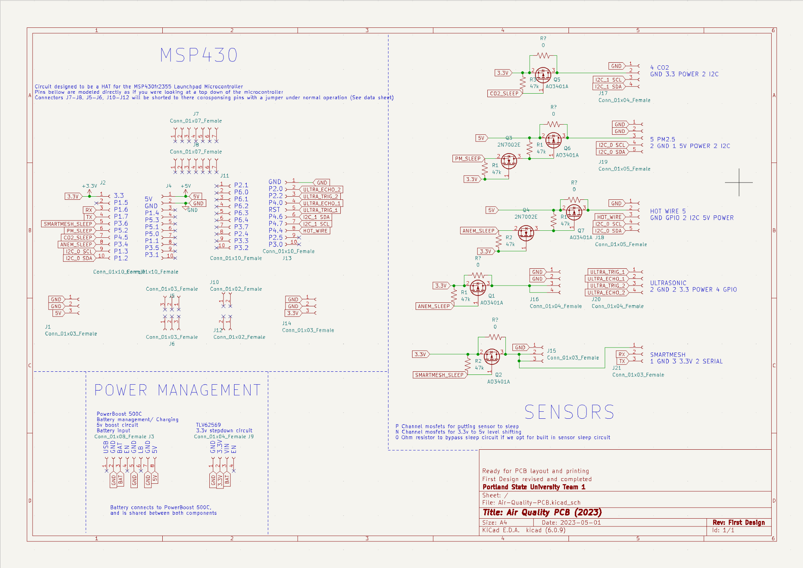

Completed PCB Schematic (Revision 1) ~ PCB layout in progress